Part 1: Run the application
I opened request-form.php and filled out the form, then hit Request session. It took me to process-request.php and it said "Request received." It listed my course, what I needed help with, the topics I picked, and the status said "Pending review."
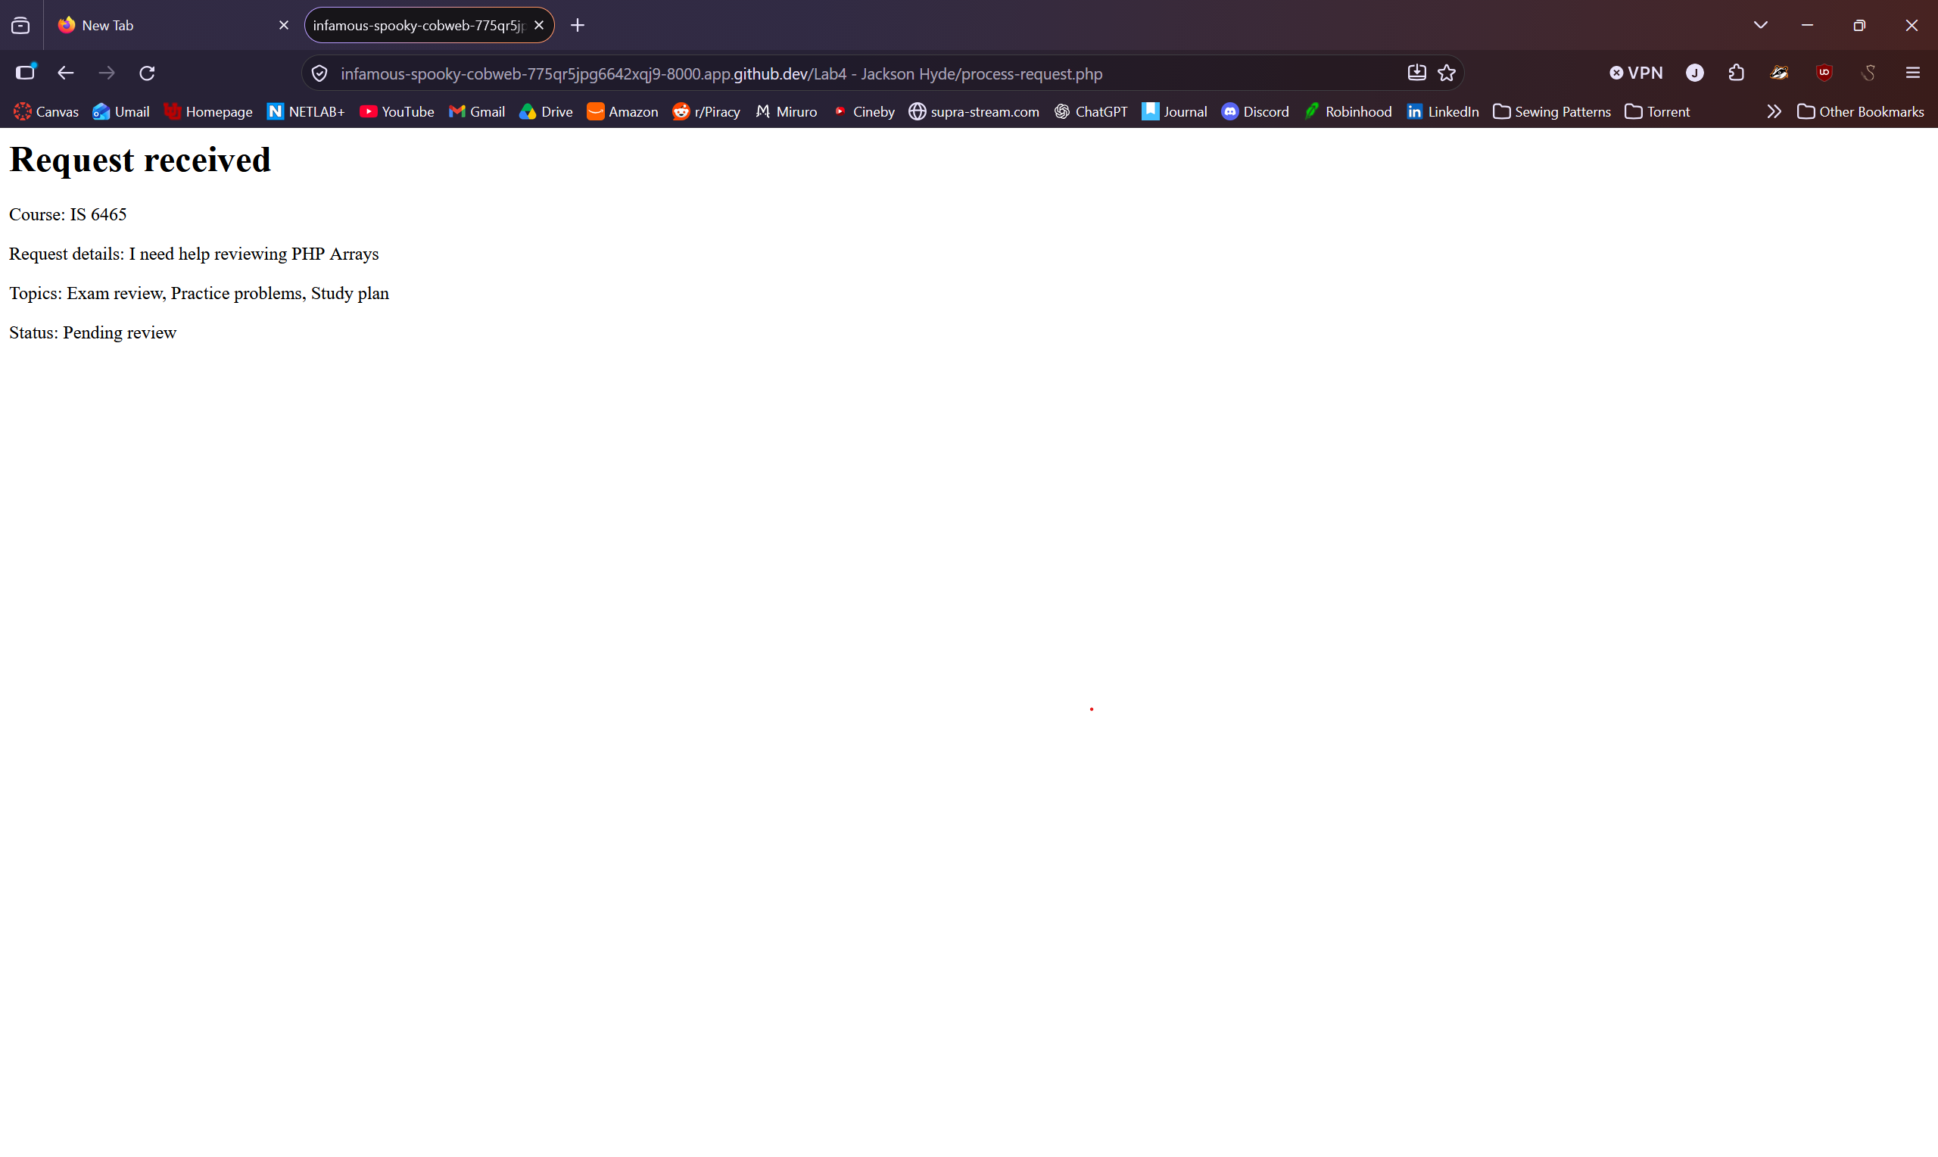
Part 2: Trace the templates
What content does header.php provide to every page?
header.php has the top part of the HTML page. It has the link to styles.css, and the title.
What content does nav.php provide?
nav.php is the menu bar at the top. It has links to the Requests page and the Request a Session page.
What content does footer.php provide?
footer.php is the footer at the bottom and it closes out the HTML.
Why is require_once appropriate for these files?
The pages need these files to work, and require_once makes sure each one only gets added once.
Where is the shared CSS file linked?
It is linked in header.php.

Part 3: Observe the form controls
reason - This is the text box where you type what you need help with. PHP gets it as a string.
topics[] - These are checkboxes so you can pick more than one topic. PHP gets it as an array.
preferredtime - These are radio buttons so you can only pick one time. PHP gets it as a string.
preferreddate - This is where you pick the date you want. PHP gets it as a string.
form_name - This is a hidden field so PHP knows which form sent it. PHP gets it as a string.

Part 4: Test validation behavior
Test 1: Valid request
Values entered: IS 6465, 2026-11-05, "I need help reviewing PHP arrays.", Exam review and Practice problems, Afternoon
Accepted or rejected: It was accepted.
Message displayed: "Request received"
Business rule checked: Everything has to be filled out with valid values.

Test 2: Missing or invalid value
Values entered: IS 6465, 2026-11-05, "Help", Study plan, Afternoon
Accepted or rejected: It was rejected.
Message displayed: "Describe your request using 10 to 500 characters."
Business rule checked: The reason has to be between 10 and 500 characters.

Test 3: Past date
Values entered: IS 6465, 2026-10-20, "I need help reviewing PHP arrays.", Exam review, Morning
Accepted or rejected: It was rejected.
Message displayed: "Preferred date cannot be in the past."
Business rule checked: You can't pick a date before today.

Part 5: Review testing and CRUD pages
All the test cases in validation-tests.php said PASS.
Create - request-form.php
Read one request - request-details.php
Read all requests - requests.php
Update - edit-request.php
Delete - delete-request.php
What query parameter appears in the request details URL?
It is request_id.
Why is a GET query parameter appropriate for viewing one request?
GET works because you are just looking at the request and not changing anything.
Why should an actual update or delete later use POST rather than GET?
Update and delete change the data, so they should use POST instead of GET.

